The Ongoing Challenge of Meeting SPS Standards in LDCs:
Evidence from the Fisheries Sector

Overview
- Compliance with sanitary and phytosanitary (SPS) standards is a process of continuous improvement which requires ongoing investment and capacity building in both the public and private sector. If trade is to serve as an engine of growth and an instrument to tackle poverty reduction, then developing countries, and Least Developed Countries (LDCs) in particular, must be better equipped to control SPS risks and to meet international standards. Technical cooperation provides a means to address shortcomings in SPS systems in developing countries.

- This briefing has been prepared by the STDF Secretariat based on desk research and case stories submitted for the Aid for Trade Third Global Review in July 2011. It draws attention to experiences and lessons related to the challenge of compliance with SPS standards in the fisheries sector in Benin, Mozambique, East Africa (Lake Victoria) and Bangladesh. These experiences have broader relevance for other countries and regions, as well as other high-value agri-food products with export importance and/or potential. They also clearly demonstrate the importance of addressing SPS capacity constraints – and ensuing adequate financial resources for this purpose – as part of the overall effort of Aid for Trade to support developing countries’ to strengthen their supply-side capacity and trade-related infrastructure, as a means to produce and trade more.

The contribution of fisheries to economic growth, incomes and livelihoods
- In general, the fisheries sector represents an important revenue earner for LDCs through the export of high value fisheries products (e.g. shrimps, lobsters) as illustrated in Figure 1. In 2008, LDCs exported 1,085,597 tonnes of fish products valued at US$2,499 million and imported 372,532 tonnes of fish products valued at US$475.3 million. The sector also plays a critical role in creating employment across the value chain, from fishing communities to processors.

- The fisheries sector is of considerable importance for the countries considered in this briefing. In Benin and Mozambique, the sector provides an important source of food, employment and revenue, representing between 3 and 5 per cent of GDP respectively. In 2008, export revenues from fishery trade totalled US$33,000 for Benin (65 tonnes) and $76 million for Mozambique (11,566 tonnes). Crustacean exports account for a large share of overall fish exports. In terms of employment, the entire fisheries sector in Benin is estimated to generate over 600,000 direct and indirect jobs. In Mozambique, approximately 500,000 persons depend on fishing activities for their livelihoods (with a large share concentrated in fish product distribution and sales. Importantly, in both countries the sector provides employment to a large number of women who are mainly involved in post-harvest activities such as handling, trading, processing and marketing.

Figure 1: Volume and value of fisheries trade for LDCs
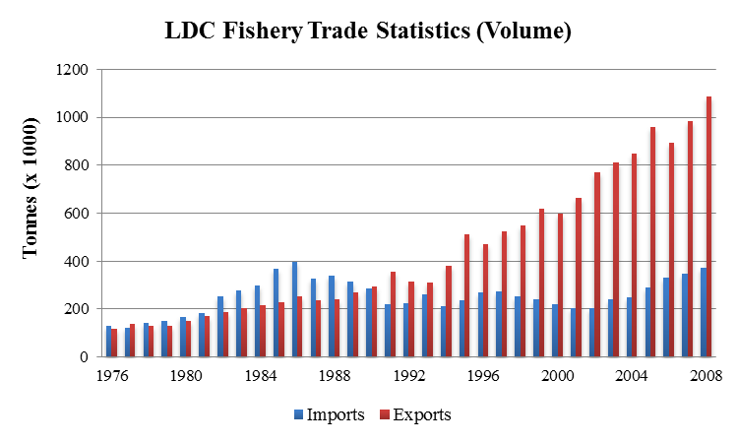

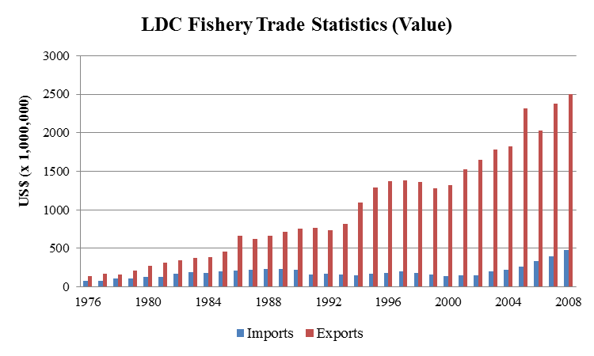

Source: FAO Global Fishery Commodity and Trade Statistics

- While LDCs enjoy duty-free access to the EU market under the Everything-but-Arms Agreement, such trade preferences do not automatically guarantee market access. Developing country exporters need to be able to comply with international SPS standards and other requirements in importing markets to export their products. Capacity to meet SPS requirements is particularly important for high-value agri-food products, including fisheries. As discussed in the examples below, weaknesses in food safety and aquatic animal health systems can block fish exports to high value markets or may result in the removal of approved suppliers for failure to comply with requirements in importing countries.

Benin
- Benin lost its export market to the EU (from 2003 to February 2005) as a result of a voluntary moratorium on shrimp exports by the Government of Benin due to EU concerns regarding deficiencies in Benin’s compliance with European sanitary requirements. An inspection mission, carried out by the EU's Food and Veterinary Office (FVO) in 2002, highlighted weaknesses in the quality control system at the institutional level, including the absence of accredited laboratories for microbiological and biochemical analyses. Although the ban was lifted in 2005, producers continued to face difficulties in recovering lost market share and lacked a sustainable process of improving fish production activities in compliance with the standards required by the international market.

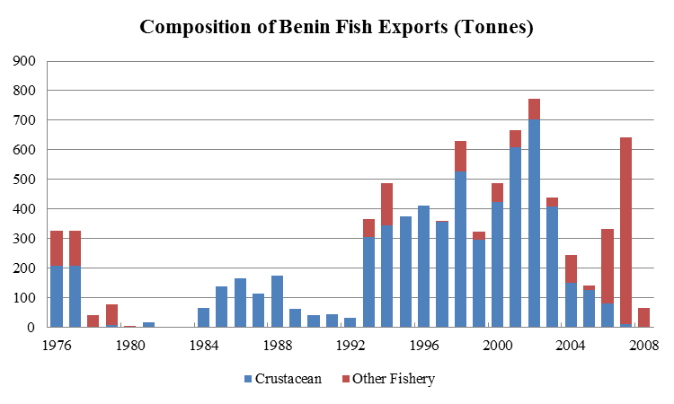
- A well-targeted response by the government, in partnership with the private sector, combined with international support, was effective in addressing the problems faced in the fisheries sector. Activities focused on strengthening the capacity of the fisheries authority responsible for SPS controls as well as improving operating conditions for shrimp production on Lake Aheme, with an emphasis on sustainable development. Inspectors, quality managers and fishing communities were trained in good hygienic practices. Infrastructure, including a central testing laboratory, cold-storage facilities, landing sites and roads, were put in place. The sanitary conditions for the production, collection and transportation of fishery products improved substantially.
Source: FAO Global Fishery Commodity and Trade Statistics
Mozambique
- Mozambique faced the potential negative consequences of losing its fish export market to the EU as a result of a 2006 inspection mission by the FVO. A number of weaknesses in Mozambique's ability to comply with relevant standards were identified such as: legislative gaps; deficiencies in facility approval, inspection, sampling and certification procedures; and an overall weak capacity of the National Fish Inspection Institute. A rapid response was required to ensure that Mozambique was not removed from the list of countries able to export to the EU.

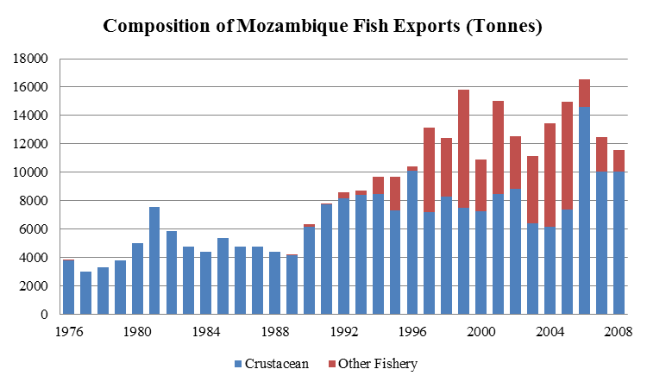
- Pre-emptive action in addressing the possible de-listing of Mozambique as an exporter to the EU market averted a crisis. Support provided by two DfID financed programmes (ComMark Trust and later TradeMark Southern Africa) enabled the National Fish Inspection Institute (INIP) to implement several standards-related projects, which ensured continued EU market access for its fisheries products. Attention focused on drafting fisheries legislation and regulations for approval by Parliament, upgrading laboratories, improving monitoring capacity, setting up a national data management system for export certification and training stakeholders in the fishing industry in food safety management. In 2007, an FVO mission to Mozambique found that over 90 per cent of concerns raised during the previous visit had been addressed, allowing Mozambique to remain on the list of countries able to export to the EU. Mozambique was also able to satisfy the South African authorities’ requirements regarding shrimp exports.
Source: FAO Global Fishery Commodity and Trade Statistics

Bangladesh
- Bangladesh has faced ongoing challenges in meeting import standards for its fish exports, particularly to the EU market, which is the largest importer of Bangladesh shrimps (accounting for nearly 50 per cent of exports). Following a five-month EU ban on the imports of frozen shrimp from Bangladesh in 1997, on the grounds of non-compliance with the EU's Hazard Analysis Critical Control Point (HACCP) regulations, exporters and the government made major investments in infrastructure to ensure HACCP compliance in the export-oriented shrimp sector. Training was undertaken to achieve international technical and sanitary standards compliance and sanitation inspection activities were strengthened. As a result of the ban, there was an increased commitment by industry and government actors to raise product quality. Despite having benefited from several technical cooperation activities implemented by various international organizations, including FAO and UNIDO, the Bangladeshi fisheries sector continues to face SPS constraints. Following an EU rapid alert notification on Bangladeshi shrimp in 2009, after unauthorized antibiotics were found in EU-bound consignments, Bangladesh voluntarily banned its exports of freshwater prawns. Serious shortcomings were also identified in the country's testing facilities by an FVO mission in January 2010, resulting in a 20 per cent stringent mandatory testing requirement by the EU authorities. Bangladesh is currently awaiting the results of a recent FVO mission conducted in March 2011.

Lake Victoria, East Africa
- During the late 1990s, citing weaknesses in food safety, the EU imposed a ban on Nile Perch imports from Lake Victoria, which affected Tanzania, Uganda and Kenya. The fisheries sector in Lake Victoria is an example of a situation where SPS issues have closed down a key export market, but also an example of how these constraints have been successfully overcome. In Tanzania, actions were taken by the Government and industry to address shortcomings in sanitary conditions on boats, at landing sites, and in fish processing facilities. Through technical cooperation (including from FAO, UNIDO, World Bank and bilateral donors), hygiene controls were enhanced, best practices promoted and overall fisheries management improved. In Uganda, through support provided by FAO, UNIDO and others, the sector recovered well over the medium to long-term, with a smaller but better equipped processing sector, improved marketing strategy and strengthened institutions. Awareness of the potential impact of non-compliance with SPS standards was heightened following the ban and government departments since then have sought to increase budgetary resources to carry out regulatory enforcement and awareness of the importance of food safety and agricultural health issues. Kenya, finally, also upgraded compliance capacity in the lake fisheries sector and managed to reduce its dependence on the EU market by accessing new markets including Israel, Singapore, Japan and Australia. A 2006 EU FVO inspection noted the excellent performance by the competent authority.

Conclusions
- Some key lessons can be drawn from the examples and experiences discussed above. Firstly, although trade problems often play a useful role in focusing national attention on the need for SPS capacity building, it is nevertheless important to encourage a pro-active approach to SPS capacity building, rather than waiting to respond to crises. This requires attention to assess and prioritize SPS capacity needs, using available assessment methodologies, and to ensure a coordinated approach to SPS technical co-operation at the country level. Secondly, it is essential to ensure that both the public and the private sector are fully committed to, and engaged in, efforts to strengthen SPS systems, and ready to share the costs of meeting the challenges faced. Thirdly, while it is important to strengthen the "software" for SPS compliance (including legal and regulatory frameworks, institutional capacity for implementing and enforcing SPS measures, SPS knowledge and skills among stakeholders all along the value chain), it is also crucial to ensure adequate financial resources for the SPS hardware and infrastructure required for compliance.

This Briefing has been prepared under the responsibility of the STDF Secretariat and does not necessarily reflect the views of STDF partners, donors or other participating organizations.
In particular case stories received from the Ministry of Commerce in Benin and TradeMark Southern Africa.
FAO National Fishery Sector Overview: Benin – January 2008. Available at: ftp://ftp.fao.org/FI/DOCUMENT/fcp/fr/FI_CP_BJ.pdf
FAO National Fishery Sector Overview: Mozambique. September 2007. Available at: ftp://ftp.fao.org/fi/document/fcp/en/fi_cp_mz.pdf
The example from Benin has been documented in the STDF film, "Trading safely", available at: http://www.standardsfacility.org/IRVideos.htm

